FRIENDS OF MONGOLIA SMALL GRANT APPLICATION
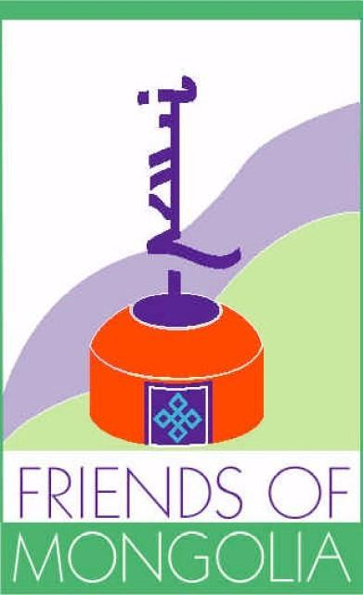
OPEN TO MONGOLIA BASED VOLUNTEERS AND COMMUNITY ORGANIZATIONS

APPLICATION DEADLINE: April 18th, 2023

Application information: Applications are reviewed, and decisions are made within one month after the application deadline. See end of this application for additional information.

Please return this application via email to grants@friendsofmongolia.org. Applications are not considered complete unless all materials requested are received. See application checklist at the end of this document.

Please answer the following questions in the order presented and numbered. Please attach any supporting documents as needed.

1. Project Title

2. Name of Organization Physical Address Mailing Address Website Address

3. Contact Information
Primary Point of Contact (name & title) Telephone Number
E-mail Address

4. Please provide the name(s) and title(s) of the officers of the organization.

5. What is the purpose/mission statement of the organization?

6. Is the organization registered/chartered? i.e. registered charity (501c3), a foundation, etc. If so, how?

7. Where will the project take place?

8. Provide the project timeline.

9. Define the project goals and objectives.

10. Please describe the criteria you will use to assess your progress and outcomes (include expected number of beneficiaries).

11. What is the total budget for the project? (U.S. Dollars)

12. How much is being requested from FOM? (U.S. Dollars)
Please attach a detailed budget, including community contribution (at least 25% of total budget). If the FOM Grant is for supplementary funding to an already funded project, please describe why additional funding is needed, what it will be used for, and how the funding will increase the overall success of the project.

13. Please identify the use of funds. Specify the Project Focus Area(s) and Activities from the categories below.

Focus Areas Activities
◻ Health ◻ Capital Costs
◻ Cultural ◻ Direct Gifts
◻ Education ◻ Operations
◻ Other (Specify) ◻ Other (Specify)

14. Describe plans, if any, for sustaining the project beyond this short-term funding period.

15. In your own words please describe how this donation supports FOM’s mission. (See www.friendsofmongolia.org)

16. Has the organization received funds from FOM previously? When and for what project?

PLEASE COMPLETE THE FOLLOWING FORM AND SUBMIT WITH APPLICATION NARRATIVE:

Project Title:

We, the undersigned, agree to the following terms when applying for funding from the Friends of Mongolia
Small Grant Program:

- Funds can only be used for the items specifically stipulated in the attached budget.
- Primary point of contact agrees to maintain correspondence with Friends of Mongolia at least quarterly through the duration of the project to provide status updates.
- A final report must be submitted to Friends of Mongolia within 30 days of completing the project, which describes project outcomes, any deviations from the project plan, project photographs (if applicable) and itemized description of all expenses including copies of receipts.
- Any unused funds must be returned to Friends of Mongolia within 30 days of project completion.
- All applications are reviewed by an independent committee and application for funds does not guarantee that funds will be awarded. The amount available for grants is not fixed and may vary each year.
- The final funding award amount is at the sole discretion of Friends of Mongolia and approved funds not collected within the designated time frame of the project will remain the property of Friends of Mongolia.

In addition, we the undersigned, certify that this project is community initiated and directed.

Project Coordinator Signature Date
(Full name typed out)

Community Leader Signature Date (Full name typed out)

Application Checklist:

◻ Verification that the project is:
1. Community initiated and directed
2. Meets a community need or interest
3. Supported by at least a 25% community contribution (direct or in-kind)
4. Well planned with sustainability in mind

◻ Detailed Budget. If the FOM Grant is for supplementary funding to an already funded project, please describe why additional funding is needed, what it will be used for, and how the funding will increase the overall success of the project.

◻ Additional supporting documents as needed.

------------

For Official use only:

Date Application Received:
Date Reviewed by FOM:
Date Applicant Notified of Decision:
Date of Project Completion:

